Lab Assignment -4

1.

Question:

Hadoop Map Reduce Algorithm

Map Reduce Algorithm Facebook friends

Description:

Created a Map Function which would take input in format of Person -> Friends list and out put the key value pairs for Reduce Function.

Screenshots:

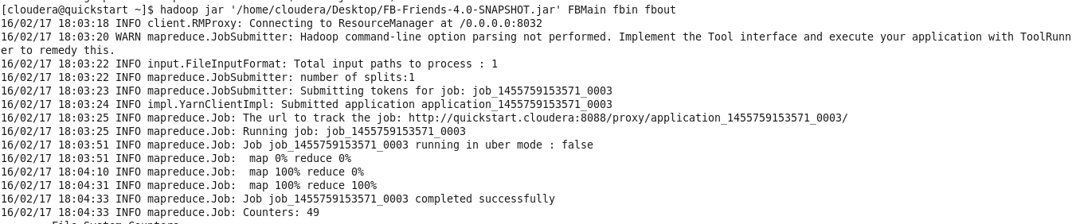

Command to execute the JAR File.

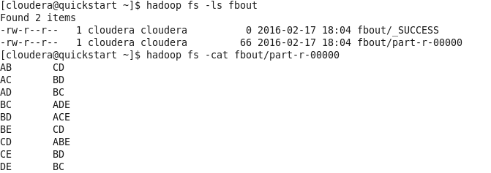

Output of the reduce function.

2.

Question:

RoboMe and Watch App

Implement a smartwatch/smartphone application using existing speech services/image services (e.g., IBM Alchemyapi, Face++) related to your project.

Description:

Used the Google Speech to text Services to capture the symptoms told by the user.

Screen Shots:

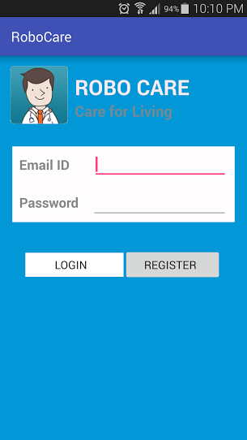

Login Form





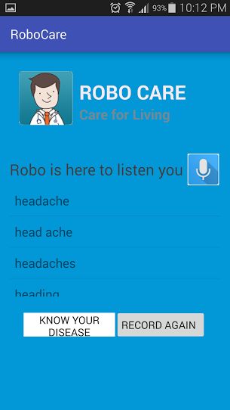

Results